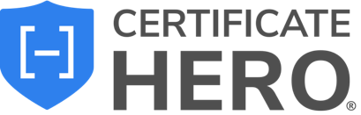

User Email Configuration – Setup Guide
Each user in Certificate Hero can configure their own email settings for sending certificates. These configurations are tied to your account, ensuring that the emails you send reflect your preferred reply-to address, message body, and signature.
This setup applies to both single certificate issuance and bundle issuance (bulk jobs).

Accessing Email Configuration

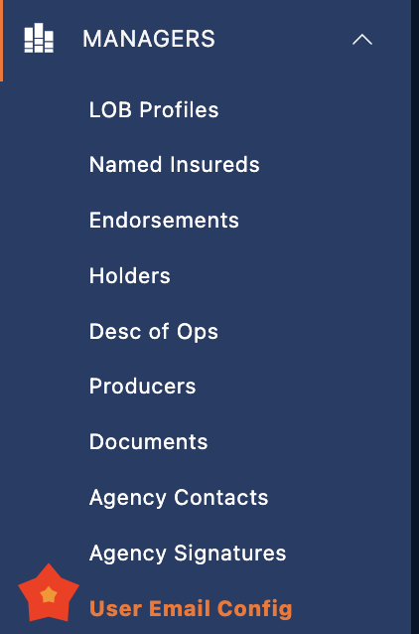
- From the left-hand User Menu, select Email Config.
- This will bring you to the User Email Configuration Manager.
Here, you will see options to customize your outbound email templates.
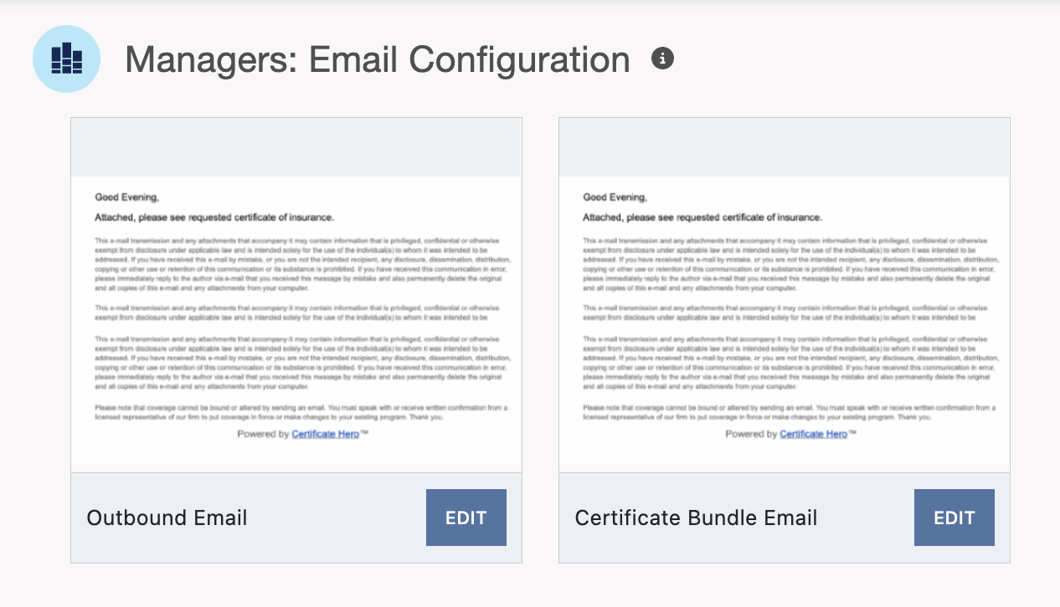

Outbound Email (Single Certificate Issuance)
When you send a single certificate via email, the Outbound Email Template is used.
You can configure the following fields:
- Reply To Email – The email address where replies should be directed.
- Body – The main message of your email (example: “Hello, please see attached.”).
- Signature – The closing line of your email (example: “Thank you, Certificate Hero Customer Success Team ”).
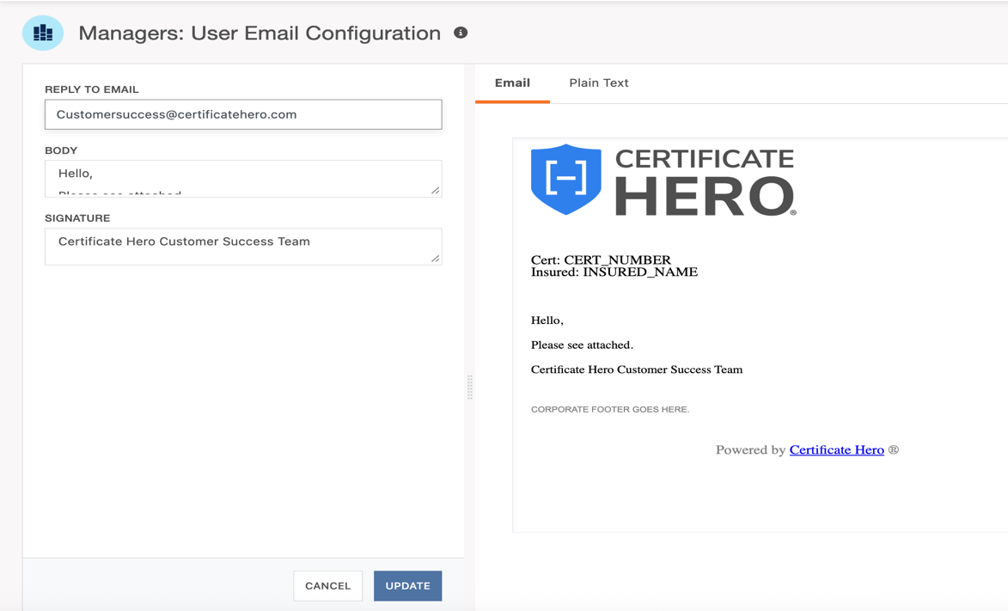
On the right-hand preview panel, you’ll see how your outbound email will appear to recipients.

Bundle Email (Bulk Issuance)
When you send multiple certificates at once (bulk revisions or renewals), the Certificate Bundle Email Template is used.
You can configure the same key fields:
- Reply To Email – Often set to a department inbox (example: customersuccess@certificatehero.com).
- Body – Typically includes a more formal message for multiple recipients (example: “Dear Valued Customer, please see the attached certificates of insurance.”).
- Signature – May be signed by a department rather than an individual (example: “Thank you, Certificate Hero Customer Success”).
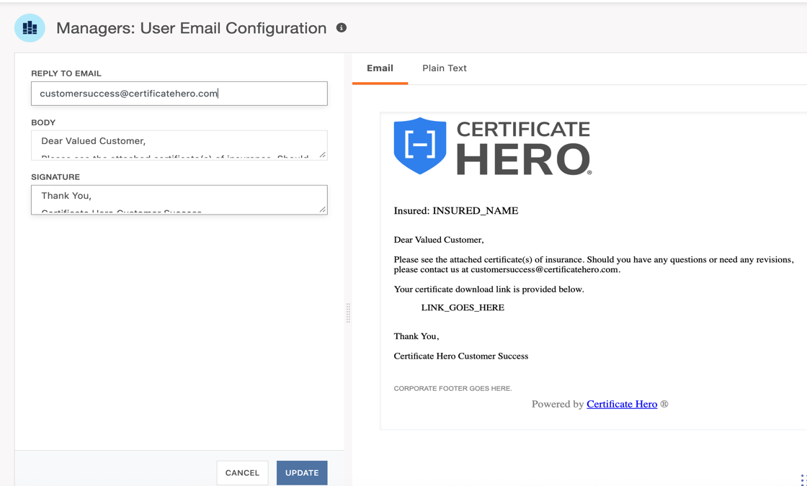
The preview panel will display how your bundle email will look to recipients, including any download links generated for bulk certificate distribution.

Saving Your Configuration
Once you’ve entered your details, click the blue Update button to save your template.
- Use Cancel if you want to discard changes.
- Your configuration is saved individually, meaning your changes will not affect other users at your agency.

Example Configurations
- Single Issuance (Outbound) – A quick, simple message with your personal contact information.
- Bundle Issuance – A more formal email sent on behalf of a department, with a shared reply-to address.

🔹 Important Note: User-Specific Configuration
Email templates in Certificate Hero are configured on a per-user basis.
- Changes you make to your Reply-To, Body, or Signature apply only to your account.
- Other team members must configure their own email templates separately.
- Agency-wide defaults are not automatically applied.
This ensures that certificates sent from your account reflect your personal or departmental contact details, while other users at your agency maintain their own.

